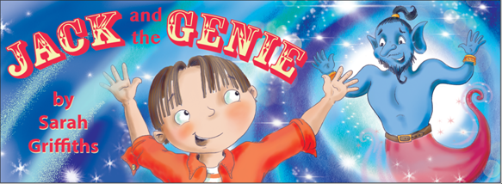
Storytelling and Mindfulness – Brownies
£75
Children’s Author and Experienced Teacher, Sarah Griffiths brings the enchanting tale of Jack and the Genie to life.
This story is about a boy called Jack who carries his sketch book wherever he goes. One day while reading his favourite story, a genie appears and Jack is magically transported into the future! Jack realises that he needs to follow his own instincts and desires. This is a wonderful tale that teaches children to follow their own inner guidance, as this is the key to reaching their dreams and finding true happiness.
Sessions include:
- Sarah shares the story of ‘Jack and the Genie’ and brings it to life with special props.
- Sarah leads a short meditation and visualisation for children based on the story, using the senses and thinking about your dream life.
- Sarah gives children time to reflect and asks children to write down what they saw or felt during the practice.
- Sarah shares a short presentation about gratitude and how it can support our day to day happiness. Children draw pictures and write about all of the wonderful things in their life that they are grateful for.
- Sarah shares the importance of taking time each day to be quiet and listen to your breath and to feel your heartbeat. Sarah shares the health-related benefits of mindfulness and meditation practices.
- The session costs £75 for up to 15 children per virtual workshop via a zoom meeting.
One session = 45 minutes.
Contact: Author Sarah Griffiths
www.sarahgriffithsauthor.co.uk
T: 07970 935241
E: sjgriffiths76@hotmail.com @sarahgriffithsauthor

