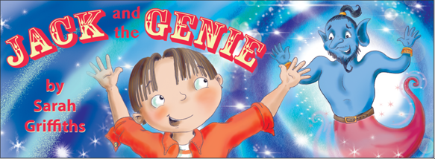
Storytelling and Mindfulness – Rainbows
£75
Children’s Author and Experienced Teacher, Sarah Griffiths brings the enchanting tale of Jack and the Genie to life.
This story is about a boy called Jack who carries his sketch book wherever he goes. One day while reading his favourite story, a genie appears and Jack is magically transported into the future! Jack realises that he needs to follow his own instincts and desires. This is a wonderful tale that teaches children to follow their own inner guidance, as this is the key to reaching their dreams and finding true happiness.
Sessions include:
- Sarah shares her story ‘Jack and the Genie’ and brings it to life with special props.
- Sarah leads the children in a short visualisation about their dream future. The visualisation is based on the story of a genie appearing and the children listen to the story. They use their senses and their imaginations to take them to beautiful places in their mind.
- The children share their favourite part of the story and what they enjoyed about the session.
- The session costs £75 for up to 15 children per virtual workshop via a zoom meeting.

One session = 45 minutes.
Contact: Author Sarah Griffiths
www.sarahgriffithsauthor.co.uk
T: 07970 935241
E: sjgriffiths76@hotmail.com @sarahgriffithsauthor

